Architectural Components – Middleware

📝Definition
# Source: AI Source: Provided by: [Data Path: Persons Table -> ID Column: 1, Name_En Column: Motasem Essam] -> From: [ChatGPT] on [1/23/2026]
Middleware is a component that sits between the Request and the Controller, allowing you to intercept, modify, or block requests and responses.
👉 Think of Middleware as a security gate or filter that every request passes through before reaching your application logic.

🔑 Responsibilities of Middleware
# Source: AI Source: Provided by: [Data Path: Persons Table -> ID Column: 1, Name_En Column: Motasem Essam] -> From: [ChatGPT] on [1/23/2026]
- Authenticate users (check login, tokens)
- Authorize access (permissions, roles)
- Log requests or track activity
- Modify request or response (headers, data)
- Block invalid or unauthorized requests

🔄 Middleware in Request Flow
# Source: AI Source: Provided by: [Data Path: Persons Table -> ID Column: 1, Name_En Column: Motasem Essam] -> From: [ChatGPT] on [1/23/2026]
Client → Request → Middleware → Controller → Service → Model → Response → Middleware → Client
👉 Middleware can run:
- Before Controller → validate/filter request
- After Controller → modify response

🧱 Examples

1️⃣ Laravel Middleware Example
# Source: AI Source: Provided by: [Data Path: Persons Table -> ID Column: 1, Name_En Column: Motasem Essam] -> From: [ChatGPT] on [1/23/2026]
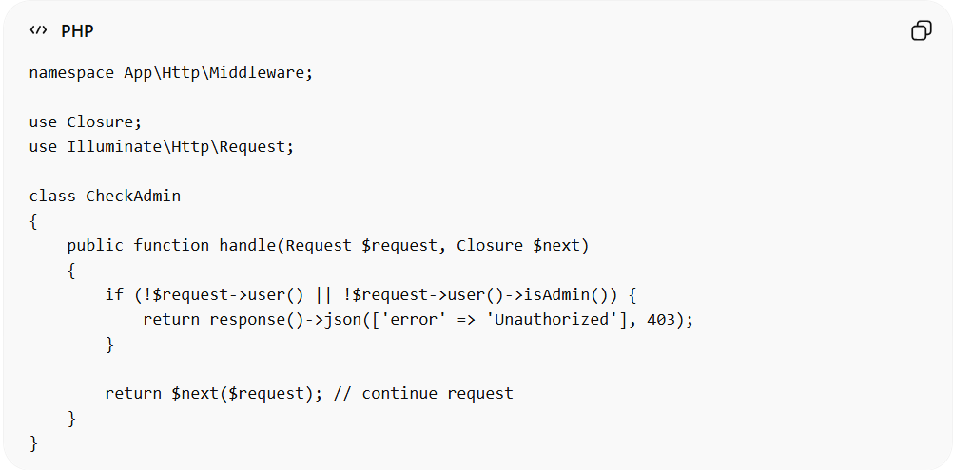
namespace App\Http\Middleware;

use Closure;
use Illuminate\Http\Request;

class CheckAdmin
{
public function handle(Request $request, Closure $next)
{
if (!$request->user() || !$request->user()->isAdmin()) {
return response()->json(['error' => 'Unauthorized'], 403);
}

return $next($request); // continue request
}
}

2️⃣ Registering Middleware (Laravel)
# Source: AI Source: Provided by: [Data Path: Persons Table -> ID Column: 1, Name_En Column: Motasem Essam] -> From: [ChatGPT] on [1/23/2026]
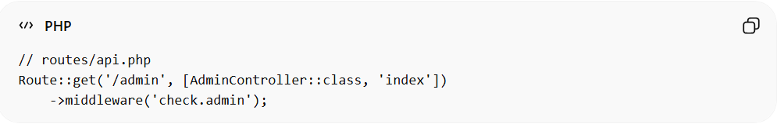
// routes/api.php
Route::get('/admin', [AdminController::class, 'index'])
->middleware('check.admin');
👉 Only authorized users can access this route

❌ Bad Example (No Middleware)
# Source: AI Source: Provided by: [Data Path: Persons Table -> ID Column: 1, Name_En Column: Motasem Essam] -> From: [ChatGPT] on [1/23/2026]
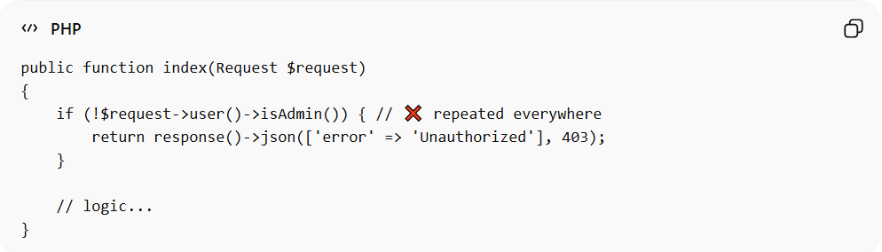
public function index(Request $request)
{
if (!$request->user()->isAdmin()) { // ❌ repeated everywhere
return response()->json(['error' => 'Unauthorized'], 403);
}

// logic...
}
Problems:
- Repeated logic ❌
- Hard to maintain ❌
- Violates DRY ❌

✅ Good Example (Using Middleware)
# Source: AI Source: Provided by: [Data Path: Persons Table -> ID Column: 1, Name_En Column: Motasem Essam] -> From: [ChatGPT] on [1/23/2026]
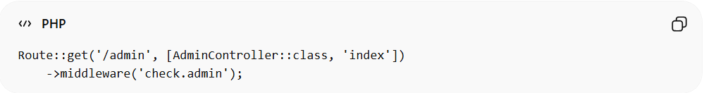
Route::get('/admin', [AdminController::class, 'index'])
->middleware('check.admin');
- Clean controller ✅
- Reusable logic ✅
- Centralized control ✅

🔄 Common Types of Middleware
# Source: AI Source: Provided by: [Data Path: Persons Table -> ID Column: 1, Name_En Column: Motasem Essam] -> From: [ChatGPT] on [1/23/2026]
- Authentication Middleware → check if user is logged in
- Authorization Middleware → check permissions/roles
- Logging Middleware → track requests
- CORS Middleware → control cross-origin requests
- Rate Limiting Middleware → prevent abuse

🔄 Relation to Other Components
# Source: AI Source: Provided by: [Data Path: Persons Table -> ID Column: 1, Name_En Column: Motasem Essam] -> From: [ChatGPT] on [1/23/2026]
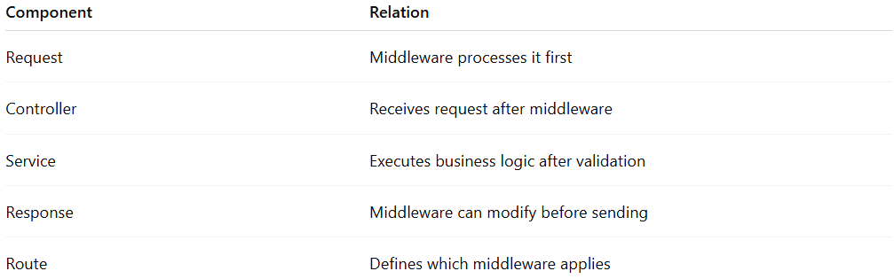
Component | Relation
Request | Middleware processes it first
Controller | Receives request after middleware
Service | Executes business logic after validation
Response | Middleware can modify before sending
Route | Defines which middleware applies

⚠️ Common Mistakes
# Source: AI Source: Provided by: [Data Path: Persons Table -> ID Column: 1, Name_En Column: Motasem Essam] -> From: [ChatGPT] on [1/23/2026]
- Putting business logic in middleware ❌
- Overusing middleware for simple checks ❌
- Not reusing middleware ❌

💡 Key Idea
# Source: AI Source: Provided by: [Data Path: Persons Table -> ID Column: 1, Name_En Column: Motasem Essam] -> From: [ChatGPT] on [1/23/2026]
Middleware acts as a filter layer that controls access and modifies requests/responses before they reach your core application logic.

🧾 Summary
# Source: AI Source: Provided by: [Data Path: Persons Table -> ID Column: 1, Name_En Column: Motasem Essam] -> From: [ChatGPT] on [1/23/2026]
- Sits between Request and Controller
- Handles cross-cutting concerns (auth, logging, validation)
- Improves security and maintainability
- Keeps controllers clean and focused

